|  |  |  |  |  |  |  |  |  |  |  |  |
| --- | --- | --- | --- | --- | --- | --- | --- | --- | --- | --- | --- |
| **Protocol**  Meeting Bachelor Thesis, FS 2024 | | | | | | | | | | | |
|  |  | | | | |  |  | | | | |
| **Protocol-No.:** | 05 | | | | | **Project name:** | Bachelor Thesis | | | | |
| **Meeting type:** | Discussion | | | | | **Location:** | GIUB, Bern | | | | |
| **Date / Time:** | 01.05.2024 / 11:00 | | | | |  |  | | | | |
| **Topic / Goals:** | Modelling for one Gridpoint | | | | | | | | | | |
| **Lead:** | Benjamin Stocker | | | | | **Logger:** | Patricia Gribi | | | | |
|  | | | | | | | | | | | |
| **Participants** | |  |  | | **E-mail** | | | **Present** | **Excused** | **Distribution** |
| Prof. Benjamin Stocker | |  | GECO-Group | | benjamin.stocker@unibe.ch | | | x |  |  |
| Patricia Gribi | |  | Unibe | | patricia.gribi@students.unibe.ch | | | x |  |  |
|  | | | | | | | | | | | |
| **Items discussed:** | | | | | | | | | | | |
| 1 Modelling for one Gridpoint | | | | | | | | | | | |
| **Next meeting:** | | | | **Attachments:** | | | | | | | |
| * 06.05.22/15.00 | | | |  | | | | | | | |

| *(Legend for type: D = Decision, P = Pending, I = Information)* | Typ | Resp.: | Date: |
| --- | --- | --- | --- |
| Modelling |  |  |  |
| * It appears that at certain grid points, PET values are higher than ET values. This discrepancy suggests a potential error in the units somewhere, which needs to be identified and corrected. Compare pet with FLUXNET values. | P |  | 29.04 |
| * **Rnet:** shortwave in – shortwave out + longwave in – longwave out. Correct? |  |  |  |
| * **Calc_patm:** Function for the calculation of the atmospheric pressure. As 'elv' (height above sea level) it would be ideal to use the information from the model grid. Is not available, the only thing found was the pressure at top level of the land model, corresponding to 2.25 millibars. Used 0 m for now. For a gridpoint same height, but when global then different heights. | I |  | 16.04 |
| * Check whether monthly totals of daily values are identical to original monthly data. No, they are not and why should they, this wouldn’t make sense. The mean of the daily values over a month should be the same as the monthly values of the original dataframe**.** |  |  |  |
| * I do not understand the annual totals. If we have daily values as monthly means the annual totals will be clearly higher than if we take the annual totals of the monthly means. |  |  |  |
| * **Interpolation:** No interpolation anymore. All days have the same monthly value. | I |  | 24.04 |
| Literature Research |  |  |  |
| * In the paper you published you take this mass balance approach. So you take the CWD as an indicator for rooting-zone water-storage capacity. In the CWD-estimation section you explain your approach and how you calculated the CWD with an algorithm. Would it be enough to cite your paper and how you calculate the CWD? Or do I have to go a step further and find a source, where there is described why I can actually take the CWD as an indicator for rooting-zone water-storage capacity? |  |  |  |
| * Root zone storage capacity (SR) is defined as the maximum of the obtained Deficit values (Global root zone storage capacity from satellite-based evaporation, p.4). Why? |  |  |  |
| Next Steps: Modelling cwd and pcwd globally |  |  |  |
| * Write function which takes as parameters et and prec and returns the cwd and pcwd timeseries. The function should be scalable. Inputs: evspsbl, precipitation. | P |  | 29.04 |
| Workflow |  |  |  |
| * Readme on infos about data download needed in the repo? I put it under data raw although it’s not the actual data |  |  |  |
| * Added reproducible workflow section under data reading and in the readme. Made a comment in the data-reading section. | I |  | 19.4 |
| * saved extracted data to files and added them to git repo | I |  | 29.4 |
| Questions |  |  |  |
|  |  |  |  |

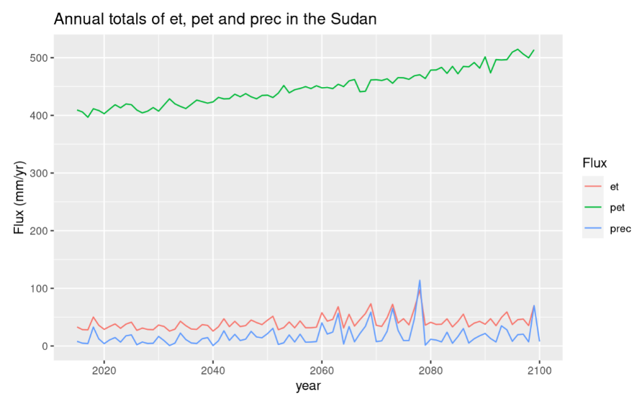**Latitude 20, Longitude 30**

In Sudan, the patterns of evapotranspiration (et) and precipitation (prec) exhibit closely aligned fluctuations, indicating a system constrained by water availability. This suggests that the runoff, the portion of precipitation that does not infiltrate the soil and contributes to streams and rivers, is likely minimal or remains relatively constant over time. Additionally, there is no significant long-term alteration observed in the storage of water resources.

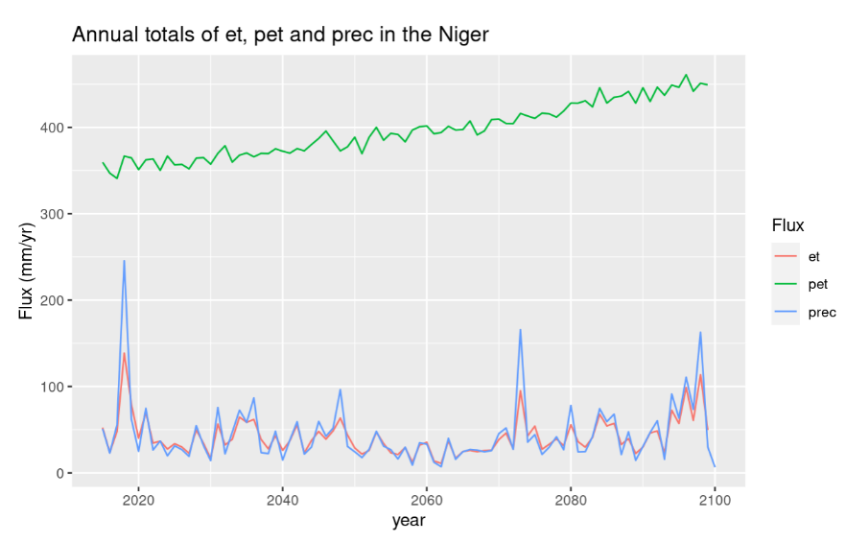

**Latitude 20, Longitude 10**

Niger, Sahara-desert

Why net radiation not negative in the desert? Shouldn’t they have an energy loss?

et close to zero because it is so dry. precipitation higher but it will instantly infiltrate in the soil and plants will need it. correct?

**Latitude -5, Longitude -62**

(Converted longitude 298)

**Potential Evapotranspiration:**

Why are there parts where evapotranspiration is higher than potential evapotranspiration?

Maybe due to interpolation of pet. Radiation was only monthly available and et daily. Can be huge difference

if for instance at the beginning of month low radiation values but in the middle of the month there would

be high values.

**Limited Solar Radiation**: Solar radiation provides the energy needed to drive the evaporation process. Reduced solar radiation, such as during cloudy or overcast conditions, can lead to lower potential evapotranspiration rates.

